|  |
| --- |
| Stratospheric Data Collection via Telemetry Using a High-Altitude Weather Balloon |



Interim Report

by Riccardo Geraci | 1615626

Friday, 14 February 2020

Supervised by Niki Zakeri

Contents

1 Abstract 3

2 Introduction 4

3 Design Research 5

3.1 Budget 5

3.2 Altitude 5

3.3 Launch 5

3.4 Software Defined Radio 5

3.5 Tracking 6

3.6 Flight Computer 6

3.7 GPS 6

3.8 Balloon 7

3.9 Parachute 7

3.10 Power Supply 7

3.11 Sensors 8

3.12 Provisional Flight Prediction 8

3.13 Provisional Balloon Calculation 9

3.14 Provisional Time-lapse Calculation 9

3.15 Configuration 11

3.16 CAD Model 12

4 Further Work Required 14

5 Conclusion 15

6 References 16

7 Appendix 17

7.1 A – Parts List and Project Budget 17

7.2 B – Excel VBA Code to Perform Totalling and Colouring Operations 18

# Abstract

Weather balloons are an invaluable tool used professionally by meteorology organisations for collecting various types of atmospheric data used in forecasting the weather. This includes collecting things such as atmospheric pressure, humidity, and temperature. Outside of the professional sector, they are highly used by radio amateurs to gather sensor data, photos, and videos of the Earth’s curvature.

The types of sensor data commonly collected by amateurs are via 3-axis accelerometers, 3-axis gyroscopes, 3-axis magnetometers, relative humidity sensors, pressure/altitude sensors, temperature sensors, ambient light sensors, and ultraviolet light sensors. These are then transmitted to the ground by telemetry via the 70cm 434Mhz HAM band to a computer connected to a radio receiver, DVB-T dongle, FUNcube Pro+ dongle, or Airspy – which is also tuned to 434Mhz with SDR tuning software in the case it’s a DVB-T dongle. The main tracking computer is typically running from inside a chase car with a magnetically roof-mounted 70cm band antenna. The GPS location of the balloon is transmitted the same way as the sensor data but with the coordinates acquired from an onboard GPS receiver connected to GPS satellites.

A service called HABhub is used by UKHAS to allow anyone around the world to track the balloon. This has an advantage of filling in any signal loss encountered by someone else relaying the GPS coordinates to the server.

Balloons of various sizes, commonly between 300-600g for first-time launchers, ascend at an ideal 5m/s until a point (usually 60,000-120,000ft depending on the balloon size and system mass, with larger and more expensive balloons achieving higher altitudes) where the air pressure is low enough (about 0.1 atmospheres) that the balloon expands to the point of rupturing. For a 600g balloon, this is 6.5m in diameter (Randall, 2019). For the best photographs of the Earth, an altitude of 25-30km/82,000-98,000ft is an ideal altitude to aim for (Akerman, 2015).

Following the balloon bursting, the payload containing the electronics descend with a legally required parachute at an ideal descent rate of 5m/s tuned by the size of the parachute selected, somewhere near a previously software predicted landing location. This is commonly between 2-3 hours away from the launch location. Lots of preparation is done to ensure the prediction is not in the ocean, airport, or restricted areas. Though prediction algorithms aren’t perfect, and the weather tends to change unpredictably, so the landing location prediction needs constant rerunning to ensure the most updated location is known.

From running several prediction tests, the average flight until the balloon bursts is usually 90-100 minutes, with a flight duration of approximately 120-130 minutes. See *3.12 - Provisional Flight Prediction* to see information about this in more detail.

# Introduction

This interim report introduces some of the research carried out from October 2019 to January 2020 in the development of a high-altitude weather balloon for obtaining sensor data from the stratosphere. The research includes learning how to build a flight tracker by interfacing a uBlox GPS chip with a microcontroller via UART serial and parsing the NMEA sentences and extracting the desired GPS coordinates and altitude. The tracker also includes a Radiometrix NXT2B which transmits the relevant sentences via traditional RTTY to the receiver antenna mounted on top a chase car. Other data protocols such as CW (Morse), DominoEX, and LoRa are also used instead of or in conjunction with RTTY and live in-flight images can be sent with SSTV (Coxon, 2020).

The majority of the research has come from Ukhas.org (UK high altitude society). They offer the single most abundant and reliable source of high-altitude ballooning on the internet with veteran members creating articles which instruct others how to launch a balloon of their own. These members have been approached by organisations such as the BBC to fabricate and launch balloons for TV and have helped directly in this project with one-to-one correspondence or through their public articles. Credit will be paid to them where appropriate in interim or dissertation. Without their contributions, this project would have not been possible to carry out due to its complexity.

The sensor modules were purchased in breakout board form with the intention of integrating them into a tracker PCB containing the other key components such as the Radiometrix NTX2B, SMA antenna connectors, and switch-mode voltage regulators. All the sensor boards use I2C to communicate with the microcontroller, which means the SDA and SCL lines will need to be interconnected with a BUS to pins A4 and A5 of the Arduino.

Switched-mode voltage regulators will be used to supply the various voltages from an external source required by the different sensors, such as 3.3v and 5v without putting too much strain on the Arduino supply.

The research into the parachute required, helium amount required, and which chase car antenna is required has been pushed towards the end of the research as it is dependent on the totals of other components. To ensure the correct parachute size is purchased or fabricated, the total mass of the system will need to be measured first to acquire an optimal descent rate/landing speed of 5m/s (Akerman, 2015).

To ensure to correct helium quantity is obtained, the system mass, balloon size, and target burst altitude/ascent rate need to be determined first. The parachute size can be determined once the system mass is measured.

# Design Research

## Budget

The budget for this project has been more expensive than anticipated. Many technical articles have quoted £200, which is quite underestimated. As of 26/01/20, not all items have been purchased and £300 has already been spent. After purchasing the remaining items, such as helium, laptop inverting charger, parachute, action camera, SD card, mag-mount antenna, and balloon, the expenses come to £498.55. This excludes £40 fuel costs to retrieve the payload upon landing 2-4 hours away depending on the effects of wind on the day of launch. *Appendix A – Parts List and Project Budget* shows the currently spent funds in obtaining the necessary equipment and parts.

## Altitude

The burst altitude is dependent on various factors such as the size of the balloon, payload weight, and rate of ascent. Common 600g latex balloons have a burst altitude of between 75,000ft - 90,000ft (Kaymont.com, 2020) whereas larger and more expensive balloons (800g-4000g) have a larger gas capacity and extended amount of stretch than smaller ones (100g-600g). So, they have a longer time of ascent, hence altitudes of beyond 90,000ft can be achieved (Kaymont.com, 2020). For this project, a 600g-1000g balloon will likely be used as they are the most commonly used latex balloons for first-time launchers and can be purchased from Steve Randall’s website; randomengineering.co.uk for

## Launch

In the UK, permission must be obtained prior to launch from the Civil Aviation Authority (CAA) before any weather balloons can be launched. An OS map pinpointing the planned launch location must be sent before permission is granted. If valid, permission and a NOTAM (notice to airmen) will be issued. Due to unpredictable weather, a window of different launch dates should be requested. 28 days prior notice must be given before the planned launch date (Stirk, 2012).

## Software Defined Radio

Software-defined radio is an inexpensive alternative to using an expensive but also more sensitive radio such as the most commonly used Yaesu 817. SDR dongles utilise the Realtek RTL2832U chipset and computer’s soundcard to decode radio signals. However, SDR dongles are repeatedly discouraged for tracking actual balloon flights due to their reduced sensitivity when compared to a proper radio. Although, this argument is conflicted by different opinions and a compromise has to be taken.

## Tracking

After launching of the balloon, a chase car with a magnetically roof-mounted 70cm band antenna connected with a length of SMA terminated RG174 cable is fed to a USB DVB-T dongle connected to a computer running SDRsharp software tuned to 434.425MHz, the same as the payload transmitting frequency. The received RTTY tones are then sent to dl-fldigi software via a virtual audio cable where the tones are decoded character by character into sentences containing the GPS coordinates of the balloon’s current position. This GPS information is then relayed to HABhub to allow worldwide tracking of the balloon (Stirk, 2012). Once the balloon lands, the perfect line of sight is almost always lost, and usually the signal with it. It is recommended to use a YAGI antenna from this point since they are highly directional and can detect faint signals (Akerman, 2015). It’s best to drive around the predicted landing location with a YAGI antenna until the signal is re-established to locate the payload (Lomond, 2019).

## Flight Computer

Original plans were to use the Raspberry Pi as per mentioned by Heather Lomond PhD, a member of TDARS amateur radio group recommended by Mohammad Sayed. The Raspberry Pi allows the use of the Pi camera which could have programmed to take photos every x seconds. Heather has launched two weather balloons before and shared her story of how she achieved it. She mentioned she used the pi-in-the-sky (PITS) flight tracker developed by Dave Akerman and Anthony Stirk. This is a tracker that is pre-made by two expert HAB members to sit on the top of the Raspberry Pi. However, due to the price of £144, an ambitious choice to develop a flight tracker was made.

A later decision came to switch to the Arduino since the Raspberry Pi in a UKHAS member’s own words is ‘hardly ideal as a flight controller’ due to requiring knowledge of running a real-time kernel, linking a c program, higher power consumption (5-10 times more than normal tracker), and has a limited about shields readily available, etc (Akerman, 2020). Most of the available sample code for GPS and RTTY transmission is written for Arduino and is difficult to reimplement in python for the Raspberry Pi without significant python knowledge.

## GPS

The GPS module chosen for this project is the uBlox Max-M8Q. This is the most commonly used GPS chip used by the HAB community because it continues to operate up to 50,000 meters when in flight mode. Not all GPS modules continue to work at this altitude and result in monotonic values. This ensures the balloon’s location doesn’t go ‘silent’ when the balloon goes beyond the operating altitude (uBLOX MAX-M8Q Breakout for Active Antennas, 2016).

## Balloon

A 600g Latex balloon from randomengineering.co.uk is going to be used to carry a payload of between 500g and 900g. The payload will need to carry 4-6 lithium AA batteries that serve as the power supply, microcontroller, tracker/sensors PCB, action camera, etc. The weight of the payload container, which is a 2.4L polystyrene box, parachute, connecting lines, and antenna, needs to be accounted for in the lifting capabilities of the balloon. The balloon has a burst diameter of 6.5m which is significantly larger than its diameter at launch (Randall, 2019).

Helium will be used as the lifting gas. It’s the most commonly used gas in HAB because it is safer to use than hydrogen and methane. Though hydrogen is cheaper and lighter (hence, has more lift) it is said to be explosive when mixed with the correct amount of air. Although, hydrogen also does not diffuse out of the balloon as quickly as helium (Coxon, 2009).

The Radiometrix NTX2B 434.425MHz 10mW transmitter is the proven workhorse of many trackers used by the HAB community. In fact, 10mW is the maximum operating power that can be used for licence-free transmission. This still allows several hundreds of miles of signal due to a perfect line of sight to the receiver when in the sky (Coxon, 2009). The transmitter is connected to a 50RG174 pigtail via an SMA connector. The antenna radiating element is cut to 164mm to achieve a ¼ wave. A 4-point radial of approximately 164mm is used to simulate a ground plane or counterpoise to increase the reflections of the radio signal (Coxon, 2014).

## Parachute

The parachute is a requirement by the CAA to bring the payload and balloon remnants back to the ground safely. The size of parachute depends on the balloon’s post burst weight. Parachutes can be found cheaply (£25), expensively (, or can be made at home using a sewing machine and nylon sheeting. Nylon is used for its strength and resistance to the cold since the temperature in the stratosphere averages at about -50 (Coxon, J, 2009).

The balloon train must also be made of nylon, usually, 1mm braided as this provides enough strength but has a low enough breaking strain as required by the CAA (Lomond, 2019). 1mm braided nylon has a breaking strain of about 22.5KG/220N, however, it is not made to precise breaking strain (Randall, 2019).

## Power Supply

The source of power for this purpose is to use disposable energiser lithium AA batteries as they are the most resilient to the cold ( to ) (Energizer, n.d.) and are energy-dense. 6 x 1.5V AA lithium will provide a 9V power supply which is expected to last around 5 hours when coupled with an appropriate switched-mode voltage regulator. However, this will depend on the total current draw from the components, which can be evaluated after the construction of all circuitry for a more accurate expected working time (Coxon, 2009). Adding another 6 in parallel will double the working time to about 10 hours (Akerman, 2015).

## Sensors

The objective of launching a high-altitude balloon was to collect data from several different sensors aboard the payload. The original intention was to gather atmospheric pressure, altitude, and temperature. But since meeting with Heather Lomond, who showed off the graphical results of her flights, several breakout boards were purchased with the intention of integrating them into a larger PCB which is connected to the microcontroller. This will include a 3-axis accelerometer, 3-axis gyroscope, 3-axis magnetometer, ambient light sensor, UV light sensor, altitude/pressure sensor, voltage sensor, internal temperature sensor, and external atmospheric temperature sensor. As of 24/01/20, most of these sensors have been tested within Arduino code and suitable library and appear to provide valid readings. The library code of some of these sensors has also been studied to understand how the internal registers are set to configure the different operating modes of the chips. A detailed explanation of how these library operations work will likely be included in the thesis.

## Provisional Flight Prediction

Calculations were made to test the prediction algorithms that will be used during the actual launch. Note: the below flight landing prediction is only valid for if the launch were to happen on 30/01/20 and will be completely unusable for the real launch several months in the future.

Figure 1- Provisional Flight Predictions for 30.01.20 Using predict.habhub.orgFigure 1 shows the hypothetical predicted flight path for a balloon launch from Priorslee, Telford at 8 am on 30/01/20. The burst altitude is supplied using a balloon burst calculator as 29,485m/96,735ft. The ascent and descent rates are left as the default ideal 5m/s. Notice how the flight path is influenced by the jet stream.

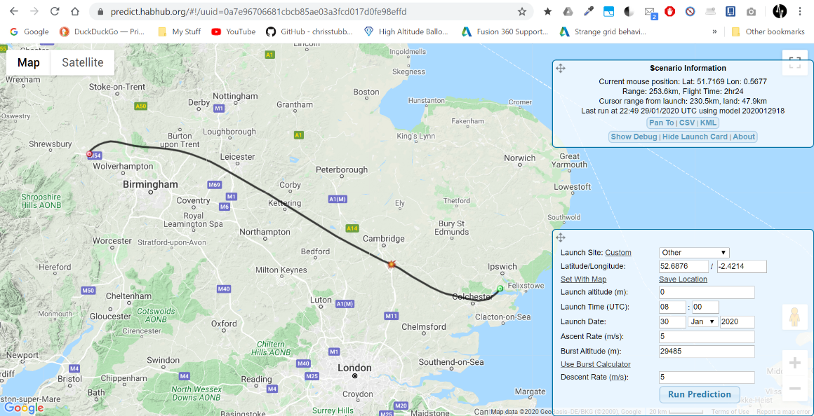

Landing

Launch

Burst

Figure - Provisional Flight Predictions for 30.01.20 Using predict.habhub.org (Geraci, 2020)

If this was treated as a real launch prediction, the launch would be postponed until the landing location prediction was further away from the North Sea.

## Provisional Balloon Calculation

Figure 2 shows the resulting key information if a payload mass of 900g (including the braided nylon cord and parachute) was launched with a Hwoyee 600g balloon with a nominal recommended ascent rate of 5m/s.

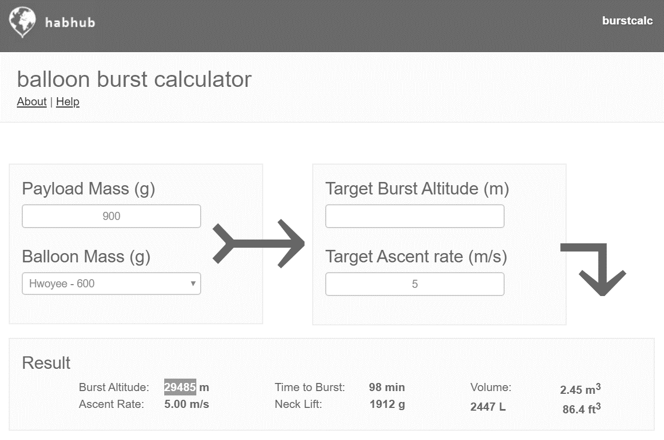

Figure - Balloon Burst Calculation Using habhub.org/calc/ (Geraci, 2020)

This gives the estimated burst altitude of 29,485m/96735ft which is then passed in as the burst altitude in Figure 1. It also shows the neck lift, which is how much lift the balloon has when filled with 2.45 of helium (Akerman, 2015). The majority of balloons require less than 3.6 of helium which comes as a BOC type ‘T’ costing approximately £100 (Akerman, 2015). The amount of helium required should not typically go beyond 3.6 as this will requite a much larger cylinder, with a more expensive price.

## Provisional Time-lapse Calculation

An action camera aboard the payload will be used to capture a 1-2s interval time-lapse of the balloon’s ascent and descent. Time-lapse is preferred over a continuous 4k video as the camera will not consume as much power and will speed up the balloon’s slow ascent and descent. Figure 3 shows the storage required if an 8MB image is captured every 2s, with an output of 24FPS. The clip length will be 3 minutes, with 33.75GB of 64GB used. The number of photos should be 4,320. 64GB is the maximum micro SD card size the action camera will accept.

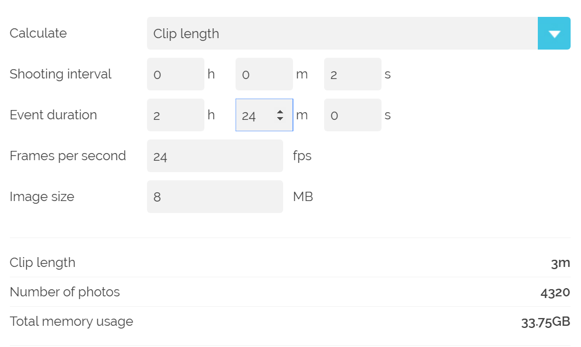

Figure - Time Lapse Showing Results of Time Lapse Using photopills.com/calculators/timelapse (Geraci, 2020)

*Manually calculating the time-lapse:*

Where i = interval, t = event duration (in seconds), F = 30, L = playback length (in seconds)

This means to achieve a time-lapse of 5 minutes long at 30 FPS, an interval of 1s would be required over the course of 2.5 hours.

## Configuration

GPS Satellite

28dbi 1575.42 Mhz GPS Patch Antenna

Ublox Max-8 Breakout Board

Arduino Microcontroller

Radiometrix NTX2B 434.425 Mhz 10mw

UART Serial

1575.42MHz

High/Low Beeps Program Output

3-Axis Accelerometer

3-Axis Gyroscope

3-Axis Magnetometer

Pressure/Altitude

Internal Temperature

External Temperature

Ambient Light

UV Light

Voltage

Sensor Module Outputs

6x1.5V Lithium-Ion AA Power Supply

I2C/SPI

Chase Car

RTTY

Mag-Mount 70cm Band Whip Antenna

164mm RG174 ¼ Wave Antenna With 4-Point Radial

DVB-T Dongle

Laptop Running SDRsharp & dl-fldigi

USB

Laptop Cigarette Lighter Inverting Power Supply

Mobile Hotspot

Habhub

GPS Data

Time Lapse Action Cam

3V/5V

5V

3V

Figure - Telemetry Configuration of Balloon (Geraci, 2020)

## CAD Model

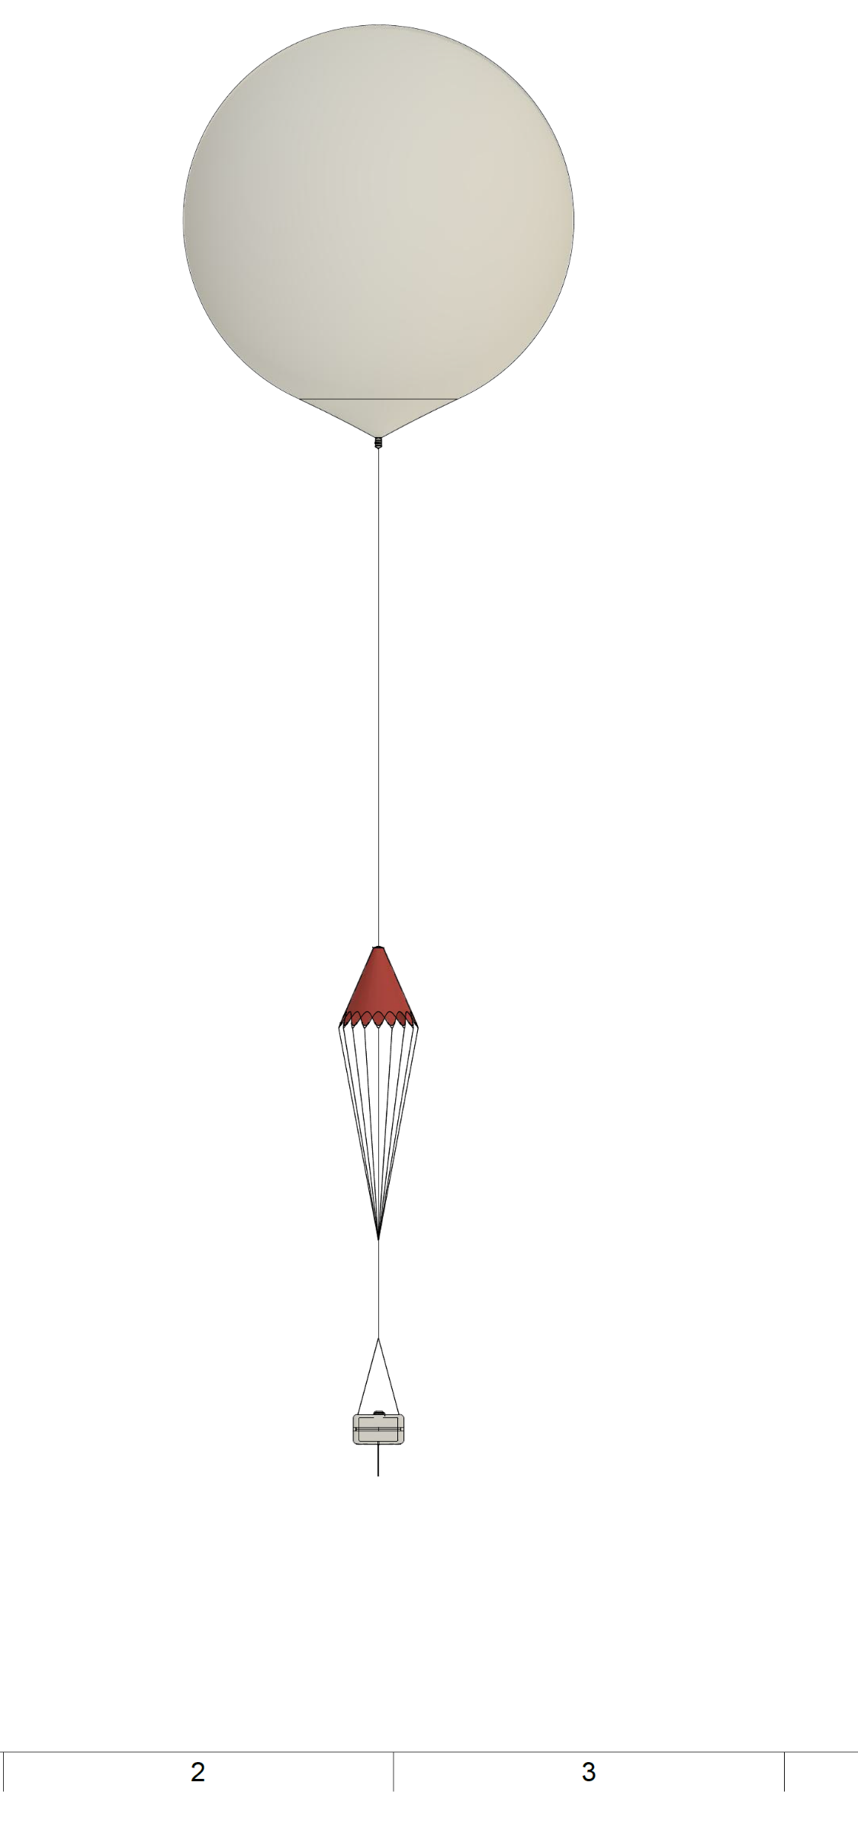

164mm ¼ RG174 to SMA Pigtail Antenna

2.4L Polystyrene Payload

600g Latex Balloon (6.5m burst diameter) (TBC)

36” Parachute (to be confirmed by calculation)

5m 1mm Braided Nylon Nylon

Figure - CAD Model Drawing of Balloon (Geraci, 2020)

5m 1mm Braided Nylon

5m 1mm Braided Nylon

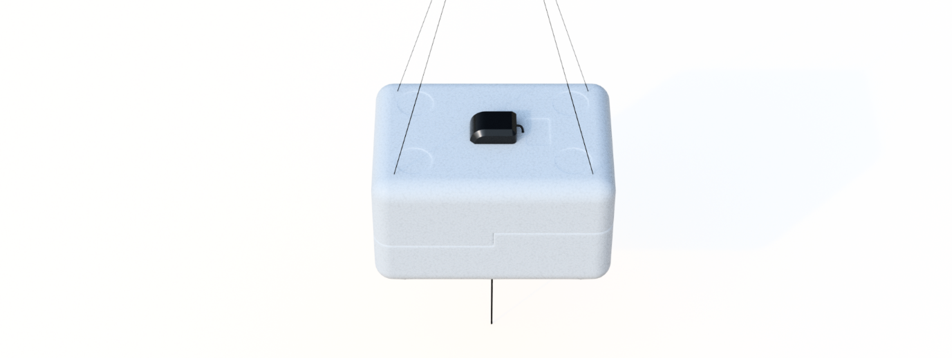

Figure - Top View of Payload Showing GPS Patch Antenna (Geraci, 2020)

**Payload (Top)**

4-Point Radial (Equipment Wire) to Simulate a Ground Plane

2.4L Polystyrene Container

28dBi GPS Patch Antenna

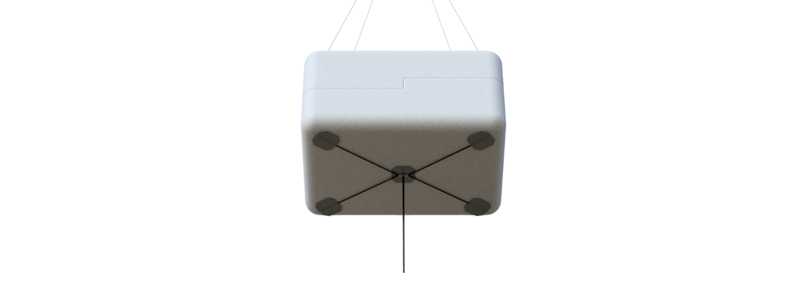

Figure - Bottom View of Payload Showing 164mm 1/4 Wave Transmitter Antenna (Geraci, 2020)

**Payload (Bottom)**

164mm RG174 to SMA Payload Antenna



Figure - Parachute (Geraci, 2020)

**Parachute**

36” Pre-deployed Parachute (Actual size to be determined later)

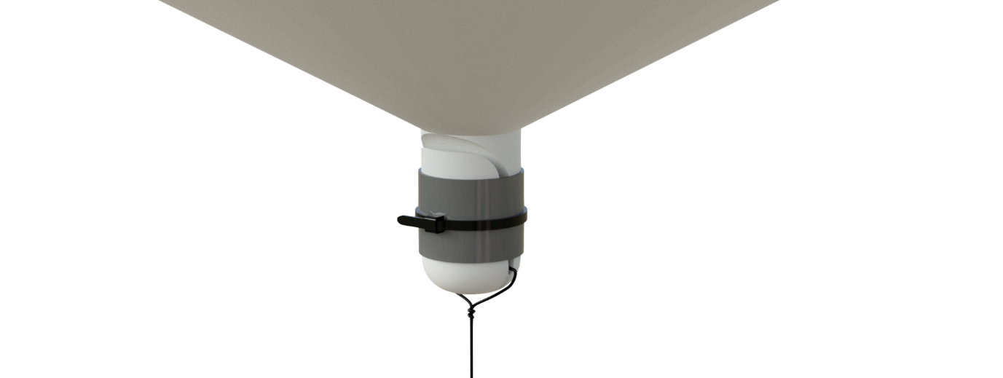

Figure - Neck of Balloon Showing Attachment of 1mm Nylon Cord (Geraci, 2020)

**Balloon (Neck)**

Hangman’s Knot

Balloon Neck & 1mm Braided Nylon Connection with Duct Tape and Cable-Tie

# Further Work Required

There is still a lot of work to be carried out in order to complete the project, with the most important areas listed below.

* Design of sensor module/flight tracker PCB hat/shield for Arduino/microcontroller
* Find out how to use the MS5661 pressure sensor to determine altitude
* Learn how to parse GPS NMEA sentences to extract GNGGA and GPRMC data
* Successfully transmit and receive parsed GNGGA and GPRMC sentences with NXT2B
* Write a program to encode and transmit GNGGA, GPRMC, and sensor data as RTTY sentences
* Determine how to relay received GPS coordinates from dl-fldigi to HABHUB
* Alert other balloonists of my launch plans
* Create 164mm ¼ wave payload antenna from RG174 to SMA pigtail
* Purchase action camera to mount inside payload to capture time-lapse of flight
* Purchase 70cm band mag-mount antenna
* Run lots of tracking tests upon completion of tracker
* Calculate, and purchase the actual balloon size required
* Calculate the actual helium amount required and find a reliable helium renting service
* Calculate, and purchase the actual size of parachute required for a landing speed of 4-5m/s
* Create a suitable power supply using a switched-mode voltage regulator(s)
* Fabricate a fill tube for inflating the balloon
* Estimate balloon true burst altitude, burst time, flight time, landing time and power supply end-time
* Purchase a laptop inverting charger to allow balloon tracking in the chase car
* Run landing location predictions frequently a week up to launch, and repeatedly after launch
* Determine a suitable launch location
* Apply for launch permission and NOTAM from CAA 28 days prior to launch
* Determine the essential kit required on the day of launch day
* Arrange for a driver to chase the balloon landing location

# Conclusion

Choosing a high-altitude balloon as a final year university project sounds simple to the inundated. While it isn’t exactly ‘rocket science’, it’s not so easy such that anyone could accomplish it either. Especially if the decision is taken to design a flight tracker themselves to save money. If one doesn’t have any experience in programming or electronics, it’s almost impossible to do without any experienced intervention. Even for the fairly experienced coder, the transmission code, NMEA parser code can be quiet a learning curve to understand. If one doesn’t know the concept of start bits, checksums, stop bits, parity, etc it can be quite cryptic.

Luckily, ballooning can be done with a modest budget of between £200-£500 which has made it accessible to many hobbyists which have helped create articles on how to design trackers, write code, and everything else required to launch successfully. However, all the available information is found in isolation, and combining it all into a working tracker is something of a challenge to figure out independently.

Contact was made with Steve Randall, director of randomengineering.co.uk, regarding this project. He offered helpful advice, on what should be omitted, how antennas should be created and what payload container to use. He runs the site where balloons and parachutes are acquired by UK balloonists.

Heather Lomond PhD, of TDARS group, offered her experience in launching high-altitude balloons. She gave a lot of information and advice via email about how she achieved her launches.

To finish this project, as discussed in *4 - Further Work Required*, the GPS strings need to be parsed to extract useful information such as the latitude, longitude, and altitude. These strings need to be encoded with RTTY transmission code, transmitted to the SDR, and decoded with dl-fldigi.

The flight tracker needs to be designed so that it utilises the Radiometrix NXT2B, sensor breakout boards, SMA connectors, power connectors, voltage regulators and external temperature probe. It also needs to slot directly on top of the Arduino header pins and secured.

Experimental tests will be carried to ensure the tracker works as expected and the transmissions are detected across long distances. Once these have been confirmed, the balloon’s mass will be measured to ensure the correct balloon size and gas quantity is obtained.

Once all physical materials are satisfactory, contact to the CAA will be made to request a NOTAM for several weekends in the following month. After this has been arranged, a kit required on launch day will be devised to ensure items such as scales, tarps, water, bottles, scissors etc are taken to the launch site.

A suitable driver will be asked to drive the chase car towards the predicted landing location so that the tracking of the balloon can be handled by the owner of the project.

# References

Akerman, D. (2015). High Altitude Ballooning, From The Ground Up (and back again) | Dave Akerman. [online] Daveakerman.com. Available at: http://www.daveakerman.com/?p=1732 [Accessed 2 Feb. 2020].

Akerman, D. (2020). guides:raspberrypi [UKHAS Wiki]. [online] Ukhas.org.uk. Available at: https://ukhas.org.uk/guides:raspberrypi [Accessed 2 Feb. 2020].

Coxon, J. (2009). general:beginners_guide_to_high_altitude_ballooning [UKHAS Wiki]. [online] Ukhas.org.uk. Available at: https://ukhas.org.uk/general:beginners_guide_to_high_altitude_ballooning [Accessed 2 Feb. 2020].

Energizer. (n.d.). Energizer® Ultimate Lithium Batteries - AA, AAA & 9V. [online] Available at: https://energizer.eu/uk/blog/product/energizer-ultimate-lithium-aa/ [Accessed 4 Feb. 2020].

Kaymont.com. (2020). [online] Available at: https://www.kaymont.com/product-page/hab-600 [Accessed 24 Jan. 2020].

Kaymont.com. (2020). [online] Available at: https://www.kaymont.com/habphotography [Accessed 24 Jan. 2020].

Lomond, H. (2019). High Altitude Balloons. [email].

Randall, S. (2019). Balloons. [online] Randomengineering.co.uk. Available at: http://randomengineering.co.uk/Random_Aerospace/Balloons.html [Accessed 2 Feb. 2020].

Randall, S. (2019). HAB Stuff. [online] Randomengineering.co.uk. Available at: http://randomengineering.co.uk/Random_Aerospace/Stuff.html [Accessed 2 Feb. 2020].

Stirk, A. (2012). general:restrictions_legality [UKHAS Wiki]. [online] Ukhas.org.uk. Available at: https://ukhas.org.uk/general:restrictions_legality [Accessed 24 Jan. 2020].

Stirk, A. (2012). guides:sdr_tracker [UKHAS Wiki]. [online] Ukhas.org.uk. Available at: https://ukhas.org.uk/guides:sdr_tracker [Accessed 24 Jan. 2020].

uBLOX MAX-M8Q Breakout for Active Antennas. (2016). [ebook] Bingley: uputronics, p.2. Available at: https://store.uputronics.com/files/HAB-BO-M8Q3A-ASSY.pdf [Accessed 24 Jan. 2020].

Ukhas.org.uk. (2014). guides:payload_antenna [UKHAS Wiki]. [online] Available at: https://ukhas.org.uk/guides:payload_antenna?rev=1417961645 [Accessed 2 Feb. 2020].

# Appendix

## A – Parts List and Project Budget

Note:

* One item is cropped off at the bottom of the list
* Green rows indicate delivered items
* Non-green rows indicated not currently purchased items, that are still required
* Some of the grey columns in totals table is written in VBA as seen in Appendix B

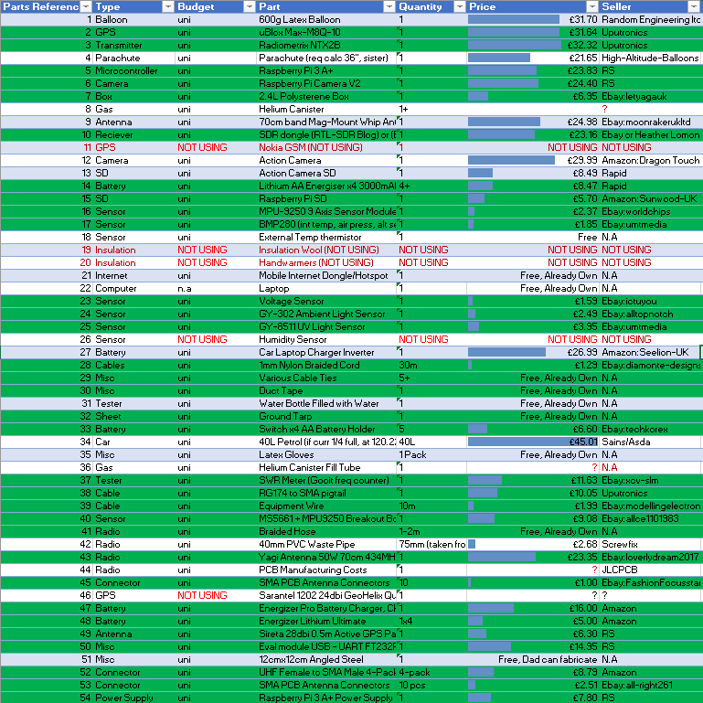 

## B – Excel VBA Code to Perform Totalling and Colouring Operations

